**User Manual**

Installation:

In below screenshot we can see the exe file.

Double click on Wandering in woods-win64



On Wandering in woods Setup page, Click “Next”

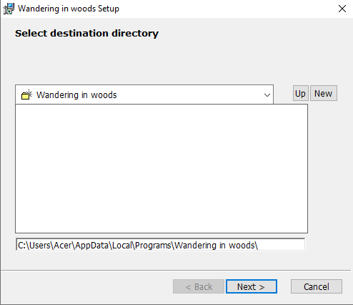

Installation starts

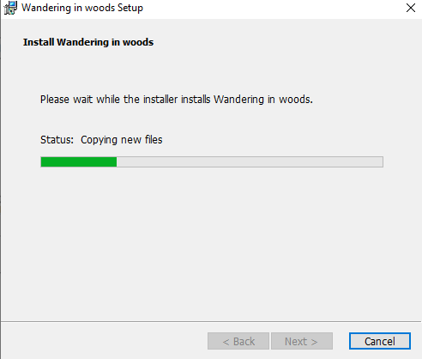

Successfully installed, Click “Finish”

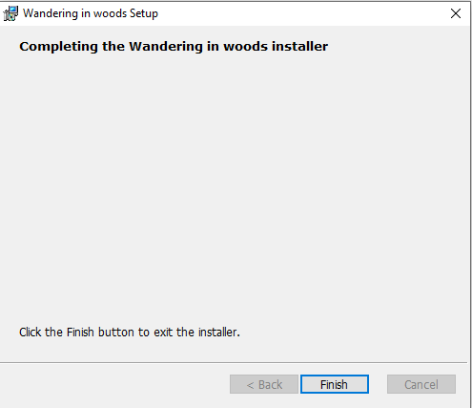

Now it is installed, and we have to open the application.

We will go to the respected folder where it is installed and click on application file.

Double click on “main”

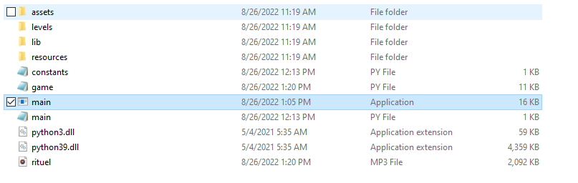

We have the main screen here,

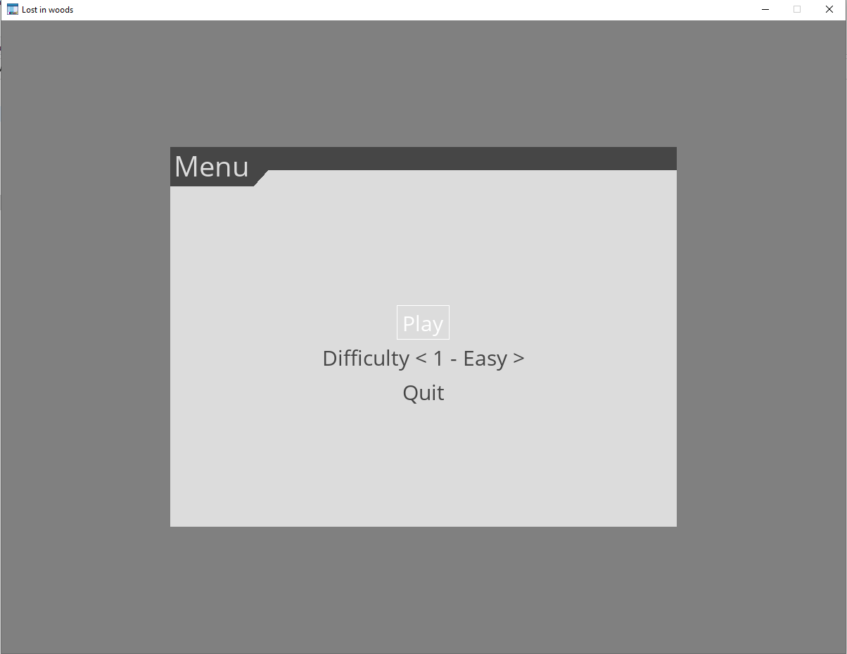

We have 3 options here, Play, We can set the difficulty level, Easy, Medium and Hard, and 3rd option is quit the application.

Click on “Play”

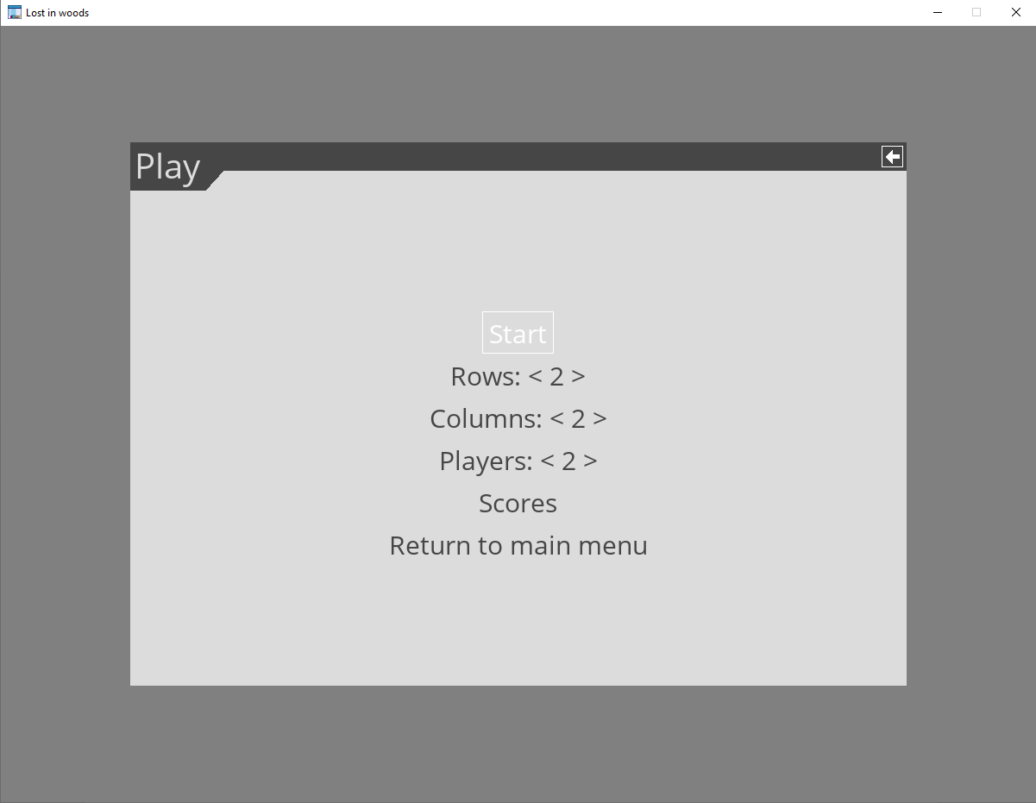

Here we can see we can choose the grid size, we can see the score, which means stats of all the levels.

After selecting the grid size and number of players we can click on Start.

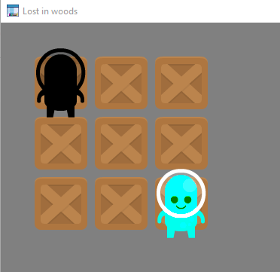

Here we have the grid and players, Black colored players is ours and the other player will move according to our player moves.

Once the both player will be at one point the game will be completed.



Here our game has completed and we can press ESC to return to the menu.

Now we will see the score.

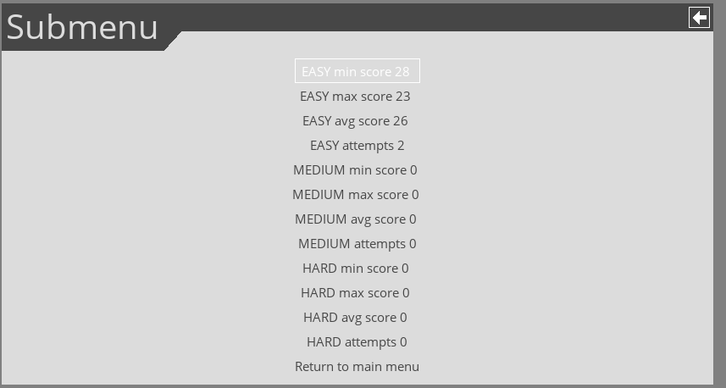

Here we can see the score since we only played easy level so only its score is displayed here.

We can use arrow keys to move the player.